**Scenario 1: capture all data.**

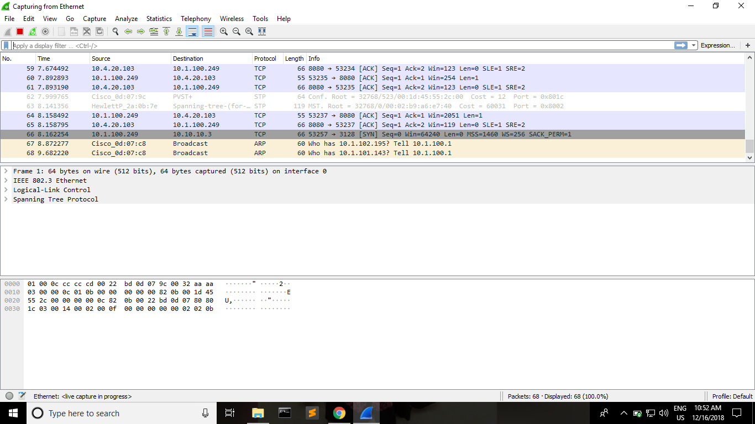

**Scenario 2: use filters to capture all data on port 3128.**

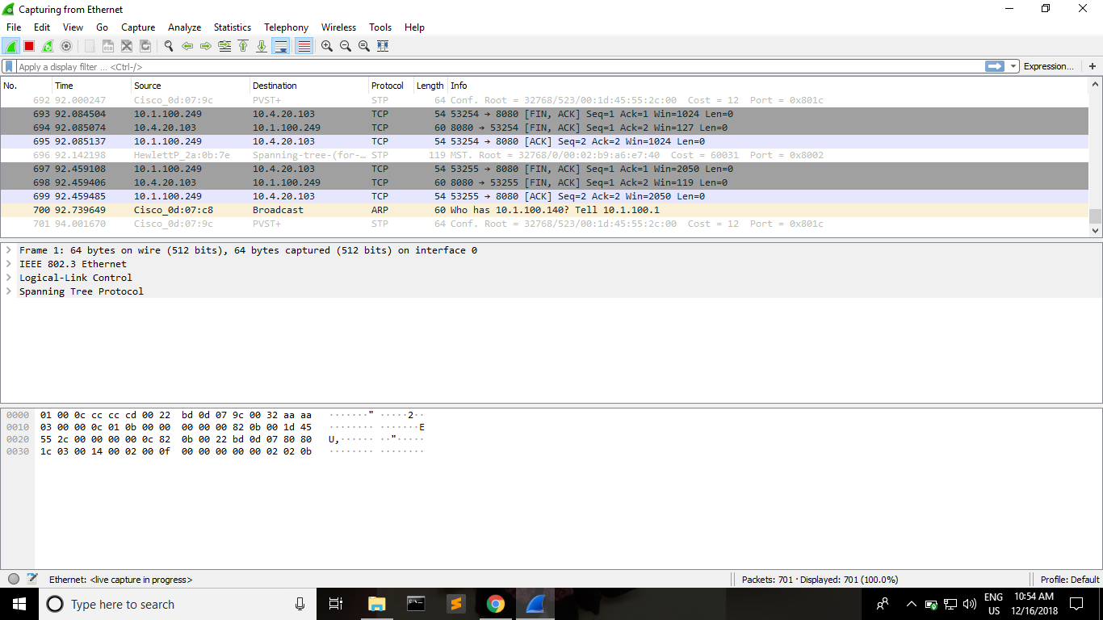

**Scenario 3: use filters to capture data originated/destined to known IP address (like google IP, your friends IP, LMS, proxy server IP)**

